**Viscous Flow in a Pipe**

ME 436 Aerothermal Fluids Laboratory

Jeremy Maniago

Experiment #2

10/20/2023

Mechanical Engineering Dept.

The City College of New York, USA

# Abstract

In this experiment, we investigate the pressure drop of viscous flow along the length of a pipe. The flowrates through the Venturi tube and through the section of pipe where the Pitot tube is will be calculated by using a manometer. Pressure taps along the entire pipe will be utilized with the manometer to get the pressures along the pipe. A Pitot tube can be connected to the manometer and can be adjusted along the radius of the tube to measure the pressures along the radius of the tube. We find that the pressure drop along the pipe trends downwards and drops significantly through the Venturi tube, then increases again. The velocity profile within the Pitot tube section of the pipe closely resembles the theoretical velocity profile for fully developed viscous pipe flow.

# Introduction

Fluid flow through a round pipe is a type of internal flow. Depending on the type of fluid and geometry/size of the pipe, the pressure profile will be different. The fluid entering the pipe will not instantly form a uniform pressure profile, as it is still developing. At a certain length along the entrance, the flow will become fully developed and laminar. Due to the no-slip boundary condition, the pressure profile will have a certain shape. There will also be a venturi tube placed within the pipe shown in Figure 1, which consists of a nozzle, where the diameter of the pipe is reduced. This will reduce the pressure and thus increase the velocity due to Bernoulli’s principle. First, we want to study the pressure drop along the pipe. Next, we will use pressure data to find the flow rate through the venturi tube by first finding the mean velocity using the equation

|  |  |  |
| --- | --- | --- |
|  | $$U_{mean}=\sqrt{\frac{2}{{\left(\frac{d_{a}}{d_{b}}\right)}^{4}-1}(\frac{∇P_{venturi}}{ρ}) }$$ | (1) |

Where da is the diameter of the pitot tube before the venturi tube (138mm) and db is the diameter of the venturi tube (90mm). The flow rate of the venturi tube is then found by multiplying the mean velocity by the small area of the tube. We can also find the flow rate measured using the Pitot tube by converting the pressure profile into a velocity using the equation

|  |  |  |
| --- | --- | --- |
|  | $$u=\sqrt{\frac{2ΔP_{pitot} }{ρ}}$$ | (2) |

We find the flow rate using the Pitot tube by using the integral

|  |  |  |
| --- | --- | --- |
|  | $$Q_{pitot}=2π\int_{r=0}^{r=wall}{u r dr}$$ | (3) |

We can then plot the velocity profile along the pipe where we used the Pitot tube to measure the pressures along the radius of the pipe. We can compare our experimental data by plotting it against the theoretical velocity. The theoretical velocity is obtained by first obtaining the maximum velocity from the experimental pitot tube velocity profile and using the equation

|  |  |  |
| --- | --- | --- |
|  | $$u_{theoretical}=u_{max}{\left(1-\frac{r^{2}}{R^{2}}\right)}^{\frac{1}{n}}$$ | (4) |

Where n = 7 for a fully turbulent case.

# Experimental Setup and Procedure

Prior to (or during) the experiment, measure the location of all the pressure taps along the tube, starting at the end of the tube opposite the blower. Turn on the blower and variac and set the variac to 45hz. Measure the pressure with the manometer for each pressure tap along the tube. For the pitot tube, measure the pressure profile along the radius of the pipe by measuring the pressure of the pitot for different increments along the radius of the tube by lifting the pitot up, using the ruler as a guide. Record all data and repeat for a variac setting of 47hz.

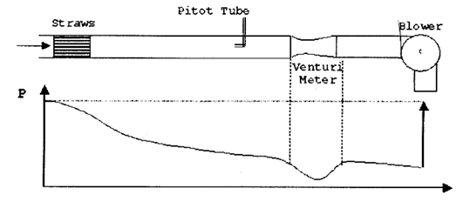

*Figure 1: Experimental apparatus and pressure diagram*

# Results

Our result for pressure drop along the tube shown in Figure 2 closely resembles the one shown in Figure 1, where the pressure drop slowly increases and shows a sudden drop in between the venturi tube, which confirms a higher velocity within that region of the pipe. Figure 3 shows the experimental velocity profile from the pressure profile measured with the Pitot tube and reveals a similar shape to that of the theoretical velocity profile. Table 1 shows the flow rates of the Venturi tube and the section of the pipe where the Pitot tube is. The flow rate is significantly greater in the Pitot tube area than in the venturi tube, which is opposite of what is expected. Figures 4 and 5 show the error bars for the velocity profile for each variac setting.

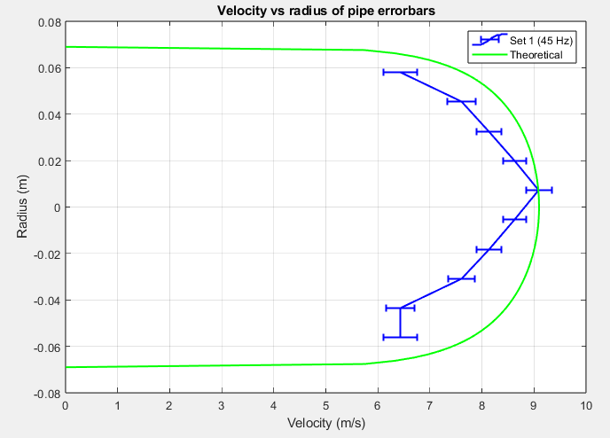

*Figure 4: Velocity profile Error bars for the 45hz variac setting*

# Conclusions

In conclusion, the experiment proves that a pressure drop throughout a pipe with viscous flow exists. A drop in pressure along the Venturi tube confirms that velocity is also greater because of the inverse relationship between pipe area and velocity Bernoulli’s equation. The velocity profile through the Pitot tube section was close to that of the theoretical profile, although the velocities were not exactly equal to its radial counterpart (not exactly axisymmetric). The flowrate through the Venturi tube was expected to be greater than that of the large section of pipe. This may be due to the real-life effects of viscous flow in that a thick boundary layer may have formed in the small area, essentially decreasing the velocity.

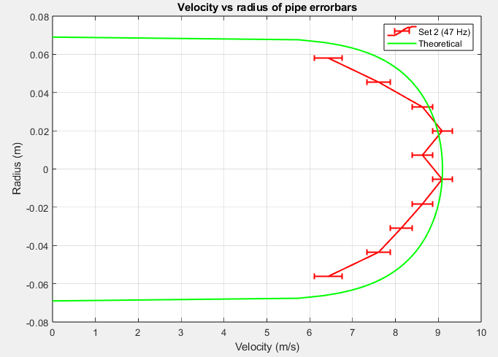

*Figure 5: Velocity profile Error bars for the 47hz variac setting*

# List of References

[1] Goushcha, Oleg. *Aero-Thermal-Fluids Laboratory ME 43600 Manual*, Blackboard, 2019

# Appendix A

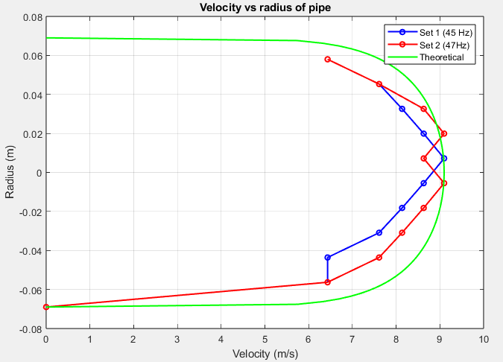

*Figure 3: Velocity profiles and Theoretical velocity profiles for different variac settings*

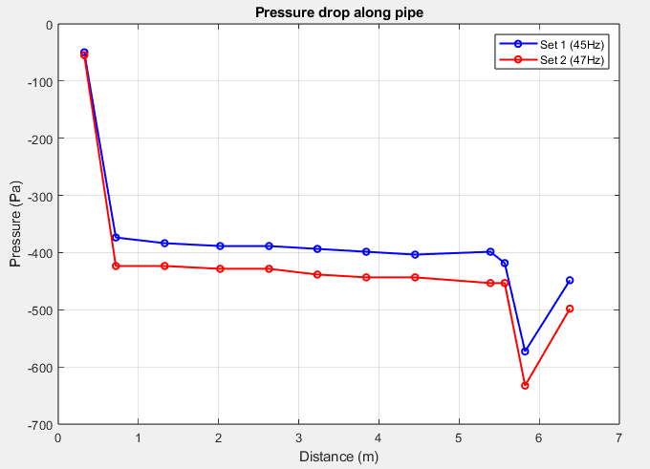

*Figure 2: Pressure drop along tube for different variac settings*

|  |  |  |
| --- | --- | --- |
|  | Flow Rate (m^3/s | |
|  | Venturi | Pitot |
| 45 Hz | 0.0479 | 0.2194 |
| 47 Hz | 0.0516 | 0.2264 |

*Table 1: Flowrates through Venturi tube and Pitot tube for different variac settings*

# Appendix B

$$ΔP_{vent.}=P\left(10\right)-P\left(11\right)=154.4296 Pa$$

$$U_{mean}=\sqrt{\frac{2}{{\left(\frac{0.138}{0.09}\right)}^{4}-1}(\frac{154.4296}{1.2040}) }$$

$$U_{mean}=7.5271 \frac{m}{s}$$

$$Q_{vent.}=π{\left(\frac{0.09}{2}\right)}^{2}*U_{mean}=0.0479 \frac{m^{3}}{s}$$

$$u=\sqrt{\frac{2ΔP_{pitot} }{ρ}}$$

$$Q_{pitot}=2π\int_{r=0}^{r=R}{u r dr}=0.2194 \frac{m^{3}}{s}$$

$$u_{max}=9.0967 \frac{m}{s}$$

$$u_{theoretical}=(9.0967){\left(1-\frac{r^{2}}{{(0.138)}^{2}}\right)}^{\frac{1}{7}}$$

# Appendix C











# Appendix D

clc

clear

close all

set(0,'DefaultFigureWindowStyle','docked')

%% 0 | Data

set(1).freq = 45; % Hz

set(1).x = [12.75, 28.25, 52.25, 79.5, 103.5, 127.25, 151.25, 175.25, 212.25, 219.25, 229.25, 251.25]; % in.

set(1).p = [0.2, 1.5, 1.54, 1.56, 1.56, 1.58, 1.6, 1.62, 1.6, 1.68, 2.3, 1.8]; % in.H20

set(1).r = [1, 1.5, 2, 2.5, 3, 3.5, 4, 4.5, 5, 5.5, 6];

set(1).delp = [0, 0.1, 0.1, 0.14, 0.16, 0.18, 0.2, 0.18, 0.16, 0.14, 0.1];

set(2).freq = 47; % Hz

set(2).x = [12.75, 28.25, 52.25, 79.5, 103.5, 127.25, 151.25, 175.25, 212.25, 219.25, 229.25, 251.25]; % in.

set(2).p = [0.22, 1.7, 1.7, 1.72, 1.72, 1.76, 1.78, 1.78, 1.82, 1.82, 2.54, 2]; % in.H20

set(2).r = [1, 1.5, 2, 2.5, 3, 3.5, 4, 4.5, 5, 5.5, 6];

set(2).delp = [0, 0.1, 0.14, 0.16, 0.18, 0.2, 0.18, 0.2, 0.18, 0.14, 0.1];

u_mano = 0.01; % in.H2O

rho = 1.204; % kg/m^3

da = 138/1000; % m

db = 90/1000; % m

%% 1 | Conversions and Pressure along Pipe

convx = 1/39.37; % m

convp = 249.08; % Pa

for i = 1 : length(set)

set(i).x = set(i).x .* convx;

set(i).p = set(i).p .* convp;

p(i).p = plot(set(i).x, -set(i).p);

p(i).p.Marker = 'o';

p(i).p.MarkerSize = 5;

hold on

end

p(1).p.LineWidth = 1.5;

p(1).p.Color = 'b';

p(2).p.LineWidth = 1.5;

p(2).p.Color = 'r';

title('Pressure drop along pipe')

xlabel('Distance (m)')

ylabel('Pressure (Pa)')

legend('Set 1 (45Hz)', 'Set 2 (47Hz)')

grid on

hold off

%% 2 | Flow Rate using Venturi vs. Flow Rate using Pitot

syms r

for i = 1: length(set)

% Venturi flow rate

set(i).ventdelp = set(i).p(11) - set(i).p(10);

set(i).Umean = sqrt( (2/(((da/db)^4) - 1)).*(set(i).ventdelp/rho) );

set(i).venturiQ = set(i).Umean .* (pi()*(db/2)^2);

set(i).venturiQ = double(set(i).venturiQ);

% Pitot flow rate

set(i).delp = set(i).delp .* convp;

set(i).r = (set(i).r - 1) .* convx;

set(i).vel = sqrt( 2.*(set(i).delp ./ rho) );

% u_times_r = set(i).vel * r;

% pitotQ = 2*pi()*( -int(u_times_r, [-da/2 0]) + int(u_times_r, [0 da/2]) );

% set(i).pitotQ = double(pitotQ);

set(i).pitotQ = 2*pi()*trapz(da/20, set(i).vel.*set(i).r);

set(i).pitotQ = double(set(i).pitotQ);

set(i).r = set(i).r - da/2;

end

%% 3 | Theoretical and experimental velocity profiles in pipe

figure;

for i = 1: length(set)

p(i).v = plot(set(i).vel, set(i).r);

p(i).v.Marker = 'o';

p(i).v.MarkerSize = 5;

hold on

set(i).velmax = max(set(i).vel);

n = 7;

r = linspace(-da/2, da/2, 100);

set(i).veltheor = set(i).velmax * ( 1 - ((r).^2)/((da/2)^2) ).^(1/n);

plot(set(i).veltheor, r, 'g', LineWidth = 1.5)

end

p(1).v.LineWidth = 1.5;

p(1).v.Color = 'b';

p(2).v.LineWidth = 1.5;

p(2).v.Color = 'r';

title('Velocity vs radius of pipe')

xlabel('Velocity (m/s)')

ylabel('Radius (m)')

legend('Set 1 (45 Hz)', '', 'Set 2 (47Hz)', 'Theoretical')

grid on

hold off

%% 4 | Error in Venturi flow rate, Pitot velocity profile

u_mano = u_mano * convp;

figure;

syms ventdelp delp

for i = 1: length(set)

% Venturi flow rate error

venturiQ = sqrt( (2/(((da/db)^4) - 1)).*(ventdelp/rho) ) * (pi()*(db/2)^2);

pventdelp = subs(diff(venturiQ, ventdelp), ventdelp, set(i).ventdelp);

venturiQ_err = sqrt( (pventdelp .* u_mano).^2 );

venturiQ_err = double(venturiQ_err);

% Pitot velocity profile error

vel = sqrt( 2*(delp/rho) );

pdelp = subs(diff(vel, delp), delp, set(i).delp(2:11));

pdelp_err = sqrt( (pdelp*u_mano).^2 );

pdelp_err = double(pdelp_err);

end

e1 = errorbar(set(1).vel(2:11), set(1).r(2:11), pdelp_err, 'horizontal');

e1.Color = 'b';

e1.LineWidth = 1.5;

hold on

plot(set(1).veltheor, r, 'g', LineWidth = 1.5)

title('Velocity vs radius of pipe errorbars')

xlabel('Velocity (m/s)')

ylabel('Radius (m)')

legend('Set 1 (45 Hz)', 'Theoretical')

grid on

hold off

figure;

e2 = errorbar(set(2).vel(2:11), set(2).r(2:11), pdelp_err, 'horizontal');

e2.Color = 'r';

e2.LineWidth = 1.5;

hold on

plot(set(2).veltheor, r, 'g', LineWidth = 1.5)

title('Velocity vs radius of pipe errorbars')

xlabel('Velocity (m/s)')

ylabel('Radius (m)')

legend('Set 2 (47 Hz)', 'Theoretical')

grid on

hold off